**MATHEMATICS FOR COMPUTING**

***WEEK 4 - SEMINAR***

## MATRICES AND DETERMINANTS

**Learning Outcomes**

By the end of the seminar the successful student will be able to:

* Determine the dimensions of a matrix.
* Add and subtract two matrices.
* Multiply a matrix by a scalar, sum scalar multiples of matrices.
* Multiply two matrices together.
* Understanding determinant of matrix.

# Introduction to Matrices

Two club soccer teams, the Wildcats and the Mud Cats, are hoping to obtain new equipment for an upcoming season. The table shows the needs of both teams.

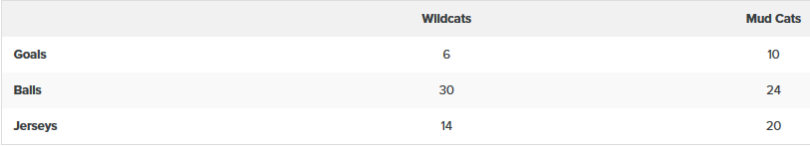

A goal costs $300; a ball costs $10; and a jersey costs $30. How can we find the total cost for the equipment needed for each team? In this section, we discover a method in which the data in the soccer equipment table can be displayed and used for calculating other information. Then, we will be able to calculate the cost of the equipment.

To solve a problem like the one described for the soccer teams, we can use a **matrix**, which is a rectangular array of numbers. A **row** in a matrix is a set of numbers that are aligned horizontally. A **column** in a matrix is a set of numbers that are aligned vertically. Each number is an **entry**, sometimes called an element, of the matrix. Matrices (plural) are enclosed in [ ] or ( ) and are usually named with capital letters.

For example, three matrices named A,B, and C are shown below.

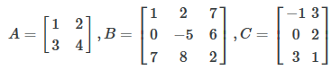

**Task 1:**

### Finding the Dimensions of the Given Matrix and Locating Entries

Given matrix A:

1. What are the dimensions of matrix A?
2. What are the entries at a31 and a22?

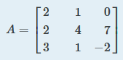

The dimensions are 3 × 3 because there are three rows and three columns. Entry a31 is the number at row 3, column 1 which is 3. The entry a22 is the number at row 2, column 2 which is 4. Remember, the row comes first, then the column.

### Finding the Sum of Matrices A and B given

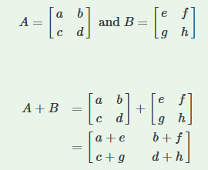

### Task 2:

### Adding Matrix A and Matrix B

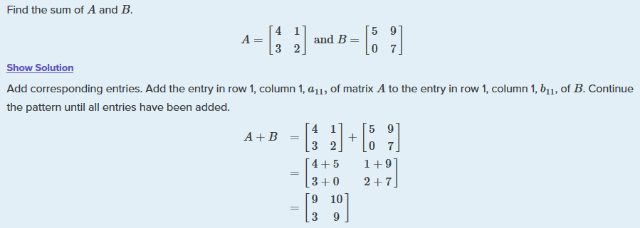

**Task 3:**

Given the matrices:

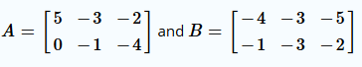

What is A+B?

A + B is,



### Finding the Difference of Two Matrices

### Task 4:

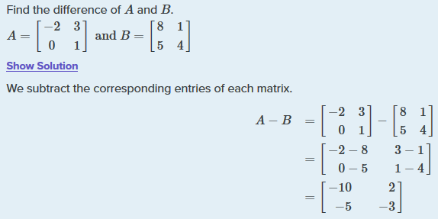

### Finding the Sum and Difference of Two 3 x 3 Matrices

### Task 5:

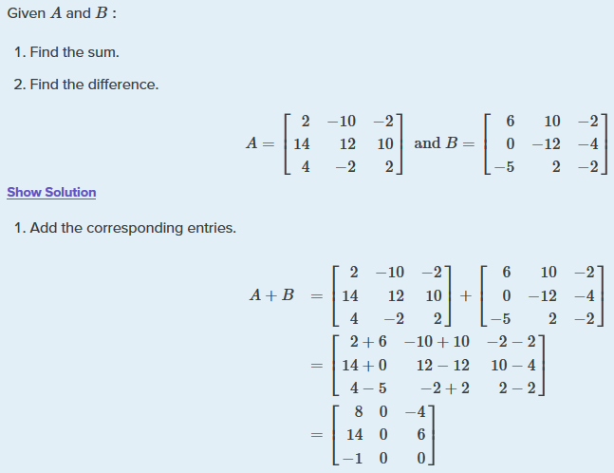

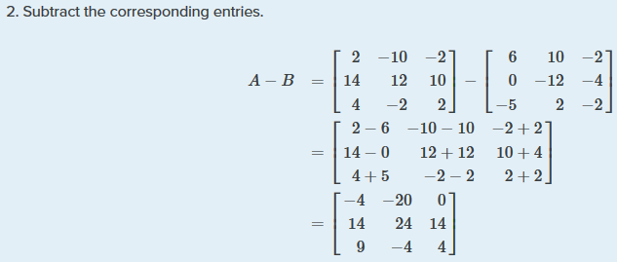

**Exercise Task 1:**

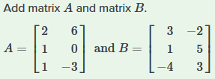

## Products of Matrices

Besides adding and subtracting whole matrices, there are many situations in which we need to multiply a matrix by a constant called a scalar. Recall that a **scalar** is a real number quantity that has magnitude but not direction. Consider a real-world scenario in which a university needs to add to its inventory of computers, computer tables, and chairs in two of the campus labs due to increased enrollment. They estimate that 15% more equipment is needed in both labs. The school’s current inventory is displayed in the table below.

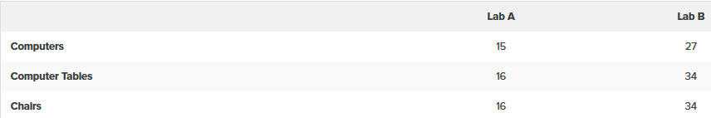

Converting the data to a matrix, we have

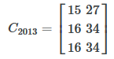

To calculate how much computer equipment will be needed, we multiply all entries in matrix C by 0.15.

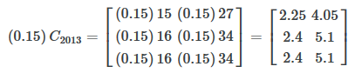

We must round up to the next integer, so the amount of new equipment needed is



Adding the two matrices as shown below, we see the new inventory amounts.

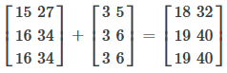

This means

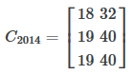

Thus, Lab A will have 18 computers, 19 computer tables, and 19 chairs; Lab B will have 32 computers, 40 computer tables, and 40 chairs.

### Scalar Multiplication

Scalar multiplication involves finding the product of a constant by each entry in the matrix. Given

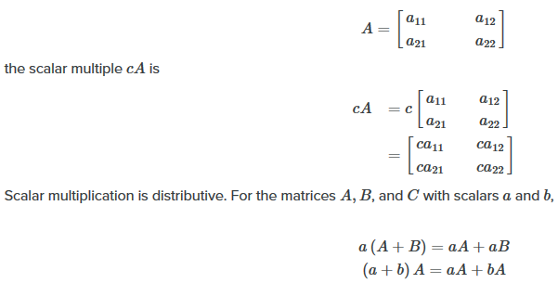

### Task 6:

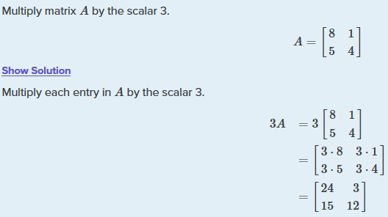

**Exercise Task 2:**

Given matrix B, find −2B where



### Finding the Product of Two Matrices

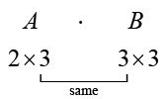

We multiply entries of A with entries of B according to a specific pattern as outlined below. The process of **matrix multiplication** becomes clearer when working a problem with real numbers.

To obtain the entries in row i of AB, we multiply the entries in row i of A by column j in B and add. For example, given matrices A and B, where the dimensions of A are 2 × 3 and the dimensions of B are 3 × 3, the product of AB will be a 2 × 3 matrix.

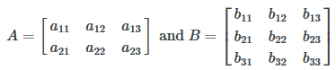

Multiply and add as follows to obtain the first entry of the product matrix AB.

xa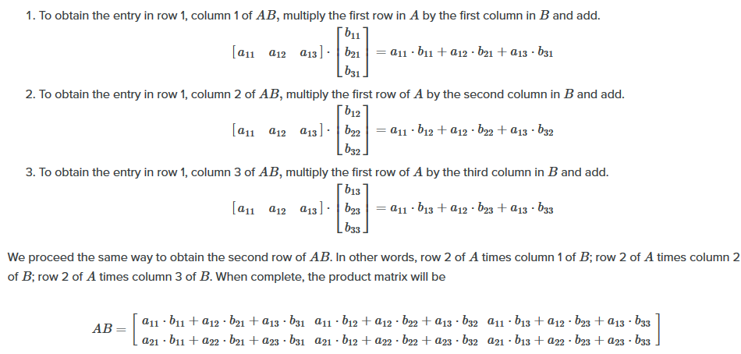

**Task 7:**

Multiply matrix A and matrix B.

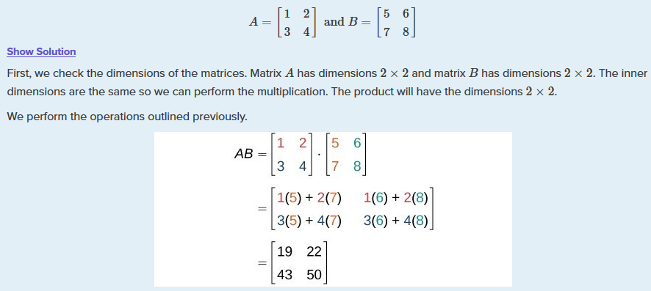

**Exercise Task 3:**

Given A and B:

Find AB

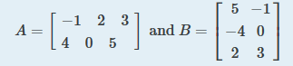

# Determinant of a Matrix

The determinant helps us find the [inverse of a matrix](https://www.mathsisfun.com/algebra/matrix-inverse-minors-cofactors-adjugate.html), tells us things about the matrix that are useful in [systems of linear equations](https://www.mathsisfun.com/algebra/systems-linear-equations.html), [calculus](https://www.mathsisfun.com/calculus/index.html) and more.

**Task 8:**

**|A|** means the determinant of the matrix **A.**

## For a 2×2 Matrix

For a 2×2 matrix (2 rows and 2 columns):

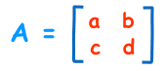

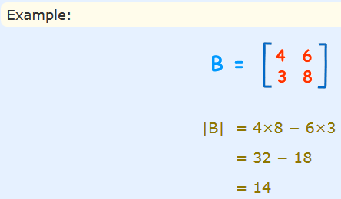

## For a 3×3 Matrix

For a 3×3 matrix (3 rows and 3 columns):

The determinant is:

|A| = a(ei − fh) − b(di − fg) + c(dh − eg)

It may look complicated, but **there is a pattern**:

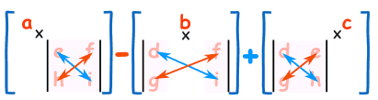

To work out the determinant of a **3×3** matrix:

* Multiply **a** by the **determinant of the 2×2 matrix** that is **not in a**'s row or column.
* Likewise for **b**, and for **c**
* Sum them up, but remember the minus in front of the **b**

**Task 9:**

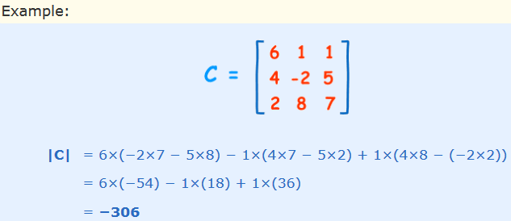

# Inverse of a Matrix

# The inverse of a [square matrix](https://mathworld.wolfram.com/SquareMatrix.html) A, sometimes called a reciprocal matrix, is a matrix A^(-1)such that

# A A -1 = I

# 

# The Inverse of a Matrix is the same idea but we write it A-1

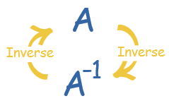

Why not 1/A ?  Because we don't divide by a matrix! And anyway 1/8 can also be written 8-1

And there are other similarities:

## Why Do We Need an Inverse?

Because with matrices we **don't divide**! Seriously, there is no concept of dividing by a matrix. But we can **multiply by an inverse**, which achieves the same thing.

## Identity Matrix

We just mentioned the "Identity Matrix". It is the matrix equivalent of the number "1":

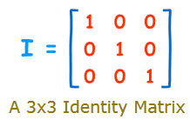

* It is "square" (has same number of rows as columns),
* It has **1**s on the diagonal and **0**s everywhere else.
* Its symbol is the capital letter **I**.

## 2 x 2 Matrix

How do we calculate the inverse? Well, for a 2x2 matrix the inverse is:

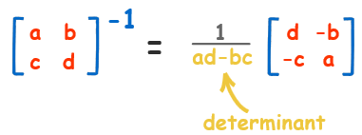

In other words: **swap** the positions of a and d, put **negatives** in front of b and c, and **divide** everything by the [determinant](https://www.mathsisfun.com/algebra/matrix-determinant.html) (ad-bc).

**Task 10:**

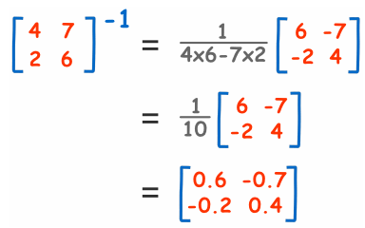

How do we know this is the right answer? So, let us check to see what happens when we [multiply the matrix](https://www.mathsisfun.com/algebra/matrix-multiplying.html) by its inverse:

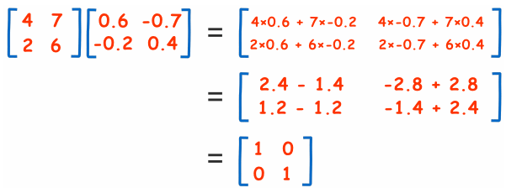

We end up with the Identity Matrix! So it must be right. We end up with the Identity Matrix! So it must be right.

**Homework Tasks 1:**

What is the inverse of the matrix?

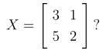

**Homework Tasks 2:**

What is AB?

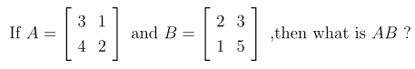

**References**

1. <https://www.khanacademy.org/math/precalculus/x9e81a4f98389efdf:matrices/x9e81a4f98389efdf:mat-intro/a/intro-to-matrices>
2. <https://en.wikipedia.org/wiki/Matrix_(mathematics)>
3. <https://brilliant.org/wiki/matrices/>
4. <https://www.statisticshowto.com/matrices-and-matrix-algebra/>
5. <https://www.youtube.com/watch?v=yRwQ7A6jVLk>